The purpose of this marketing and communication plan is to outline the Dukes County Health Council’s approach to disseminating relevant public health-related information internally among council members as well as externally to the Martha’s Vineyard community. As an organization with a wealth of knowledge concerning a variety of public health initiatives and services on the island (some of which originated from the council), DCHC has potential to serve as an important resource for health related information to islanders. To become this resource, the council will need to have a clear plan of how to effectively reach and engage the community, and how to promote its work. Based on extensive informational interviews and a short survey completed by several members of the council, we have developed this document as a basic strategic roadmap to guide the council’s effort as it strives to make itself more accessible to the Vineyard community.

Through the aforementioned informational interviews and the survey, we were able to identify a number of public health concerns that members deem as deserving the council’s attention. Housing insecurity, substance use disorders, healthy aging and oral health were identified as major public health concerns by a majority of interview participants. Mental health, COVID-19, shortage of primary care health professionals, and specialized medical care on the island were recognized by several participants as needing attention of the council. Tick-borne illnesses was the most mentioned class of infectious disease outside of COVID-19. Access to healthcare, climate change/emergency preparedness and vaccine hesitancy were additional concerns identified by interviewees, albeit with a lower degree of urgency.

Substance use disorder (SUD) was the second highest concern of interviewees and several facets of the problem were discussed. Some members of the council with expertise in the area emphasised the need for stronger prevention efforts, and highlighted the need to target adolescents attending middle and high schools. Similarly, particular aspects of healthy aging such as lack of access to affordable transportation and shortage of in-home care workers were discussed. Many participants believed lack of transportation to be a most pressing issue when it comes to healthy aging. The lack of primary and specialized healthcare personnel on the island correlates directly with transportation issues as the shortage of care on the island forces residents to travel to the mainland, which can be especially challenging for the elderly.

The shortage of both primary care and specialized care personnel on the island has been attributed to housing insecurity by participants. This is due to healthcare personnel struggling to live on the island due to expensive housing and living costs. In fact, housing insecurity (and high cost of living in general) was recognized as an all encompassing issue that compounds most of the other health concerns identified by participants.

Oral health is another priority that participants deemed as deserving more attention. Particularly, dental care for children and those without health insurance was highlighted as a significant problem. Similarly, several participants thought children and adolescents were underserved in the realm of mental health services and called for increased focus on the issue. This concern relates back to shortage of specialized healthcare personnel as mental health professionals including psychiatrists are reported to be of short supply on the island.

The COVID-19 pandemic was identified as the single most concerning infectious disease on the island. Many participants conveyed that the pandemic response in Martha’s Vineyard was hindered by the lack of a united/centralized public health entity on the island. The absence of a centralized health entity was an issue that surfaced repeatedly when discussing many other health priorities. Additionally, vaccine hesitancy was identified as an important health concern due to its potential to cause a serious public health crisis in the long-term if not addressed proactively. Tick-borne illnesses are another worrisome health priority highlighted by members, including those who are medical providers. Lastly, access to healthcare, especially within immigrant and seasonal populations, and climate concerns (rising sea levels, wildfires etc), were recognized by participants as topics that warrant attention.

All of this being said, it is important to note that the council does not yet have direct input from a significant portion of the community regarding public health priorities. Therefore, over the course of the next couple of months, we recommend that the DCHC take steps to gain insight into what the community believes are the key public health issues on the island. Before engaging in disseminating health information that the council assumes to be useful, it is important that DCHC gives islanders an opportunity to have their voices heard.

We recommend gathering islander input in a variety of ways. We suggest requesting feedback from the website, which will be published by December and will soon be fully updated with resources, datasets, and other useful information. We also recommend holding community listening forums, where community members will be invited to engage with DCHC, share knowledge, and communicate with fellow islanders. This forum will give community members ample opportunity to express concerns, needs, and solutions to public health issues of the island. Additionally, we encourage council members to conduct outreach among peers, family, friends, coworkers, and constituents in order to promote word of mouth as a method of communication and information gathering.

By becoming more active and consistent in communicating with islanders through council member outreach, the local papers and media, sponsorship of various public health initiatives, and holding listening sessions, among other approaches, the DCHC will be able to meet the community where they are and gather an unbiased and all-encompassing report of needs from the perspective of the community.

As it strives to engage in a two-way communication with the Vineyard community, it is imperative for the DCHC to have a clear sense of how it should be perceived by the community i.e the council’s brand. To this end, we conducted a survey of DCHC members to clarify what sort of community presence the council should strive for, which will inform its communication and marketing strategies. Overall, the survey (referenced in the appendix) indicated that most DCHC members agree that the council “should be an organization that actively promotes community-wide health and wellness through its support for a cooperative, integrated health care network and through public education” (72.73%). This outcome is consistent with the original mission statement of the council. Currently, the council is a fairly inconspicuous organization on the island but with a well planned marketing and communication strategy, it can better promote and establish its presence in the community.

It is important to note, however, that the most basic component of DCHC’s function is to facilitate internal communication between members. For this reason, we recommend that the council first create methods for communicating more effectively among members and the organizations they represent beyond monthly meetings. For instance, we suggest that the council strives to engage members who miss monthly meetings due to various reasons, but are nevertheless important assets to the community, through personal email or phone calls to loop them back into the activities of the council. Additionally, we recommend that the council performs regular assessment of members’ perception of whether their ideas are valued and given due consideration in order to straighten out any miscommunication within the group early on and encourage inclusive decision making.

A key goal of the aforementioned survey administered to DCHC members’ was to gauge their opinions regarding the council’s external communication strategies. Those surveyed consistently felt that while internal communication is key, the council should continue to establish and nourish communication channels with the public. With that being said, 40.91% of the 22 surveyees felt that DCHC communication to the public should be more regular and purposeful, stating that the council should consider dedicating resources like time and personnel to achieve its communication goals. On that note, 22.73% of the 22 surveyees also felt that DCHC should focus on enhancing communication with the public by using various channels like e-newsletters, e-mailers, and the website on an as-needed basis. In contrast, 36.36% of the 22 surveyees felt that DCHC resources would be better utilized by focusing its communication effort on a few more focused channels instead of pursuing several approaches.

To achieve effective communication with the Martha’s Vineyard community, members have suggested several outlets that could be utilized by the council. One of the most recommended outlets with great potential for extensive reach is the DCHC website. To a question pertaining to ownership of web and other communication content in the survey, a vast majority (65%) of members found the most important role of web and other communication content is to provide information about relevant health-related services available from their respective agencies. This majority also felt that all members of the DCHC should take initiative to consistently provide information about relevant health-related services as input for the website. Of the 65% of the members who felt that all DCHC members should consistently provide the information about relevant health-related services, 61.5% felt that each member or health agency who provides such information should be responsible for preparing and maintaining content to be posted on the DCHC website. Conversely, the remaining 38.5% expressed that preparing and publishing content for the DCHC website should rest solely on the communication committee. Lastly, some members surveyed felt that all meeting minutes, presentations, council contact information, and other relevant clerical documentation should be shared publicly on the website in order promote transparency, while a smaller number of members felt that such information should be uploaded to the website but should be accessible only to council members.

Currently, the website is being updated with information and resources on health concerns deemed important to the island community per the interviews conducted in September and October. Previous work on the website, which is still currently hosted on Wix, has mainly consisted of compiling and organizing relevant content under the website’s “Primary Health Concerns” buckets, which include Lyme Disease, Substance Misuse, Affordable Housing, Healthy Aging, Covid-19, Food Insecurity, Mental Health, Primary and Specialized Care, and Oral Health. Looking forward, council members with vested interest in particular health topics will be encouraged to take ownership of web content pertaining to that topic (consistent with the survey outcome). To streamline this process, we recommend that the website transitions from Wix to WordPress, which is a more up to date platform that has several features that permit superior content moderation. This way, directly contributing to the website will be more seamless for involved members. Other website features that we suggest be added in the near future include links where users can ask questions of the council, reach a council member, and request push notifications about content of interest. Upon completion, we recommend that the website be equipped with a proper intranet firewall and undergo usability testing. Lastly, translation of web content to Portuguese and Spanish is a crucial task that needs to be undertaken to increase the accessibility of the website.

Given the above recommendations, the council may need to consider enlisting the aid of an intern (paid or otherwise) to assist in the transition to WordPress, and to oversee the population of the website with additional content (in addition to contributing to other outreach efforts).

Another highly recommended approach to easily and effectively disseminate information from the council to the public is establishing permanent columns on the widely read Martha’s Vineyard Times and Vineyard Gazette newspapers. Many council members recommended publishing at least one article per-month highlighting relevant information regarding the council’s monthly meetings, newly available public health services, and other resources. Consistent presence on the local papers is bound to bring the council and its messages to the attention of the public.

In addition, monthly physical or electronic mailers/newsletters are important communication channels that will go a long way to convey the council’s messages to the community. Sending out mailers invokes a feeling of personalized outreach which will help garner awareness about the council. We recommend that the DCHC start with a monthly e-mailer with similar content to the aforementioned newspaper articles, particularly to reach the younger population of the island.

Creating a social media account for DCHC is another strategy that will have a great impact on the council’s interaction with the public. Similar to the website and newspaper approaches, members of the council can take responsibility for content that will be posted by the account. Again, it may be important to enlist the support of a social media-savvy associate in order to establish and grow a following for the social media account. On a similar note, it will be wise to develop a logo for the council and use the logo in all physical as well as web publications.

Another approach that can be incorporated into the council’s communication strategy is preparing webinars and workshops focusing on various health priorities and opening them up to the press and public. The council already hosts such events and by slightly adjusting them to accommodate participation from interested community members, it can significantly increase engagement with residents of Martha’s Vineyard. Additionally, we encourage the council’s current practice of publishing position statements and sending out letters to policy makers to continue with renewed dedication.

Lastly, another effective way to increase the council’s outreach and public engagement is through sponsorship and/or endorsement of various island initiatives such as the Diaper Bank by Martha’s Vineyard Community Services and the Housing Bank by the Coalition to Create the Martha’s Vineyard Housing Bank. Sponsorship can take the form of writing letters of support, publishing information about the initiatives on the council's website, having members attend various events organized to support the programs etc. Involvement in such initiatives that have a direct or indirect relationship with social determinants of health and are value-adding to the island community can help DCHC assume its duty as an advocate for improved public health on the island.

To conclude, attached in the appendix is a Gantt chart that outlines our recommended approach to strengthening the council’s public presence over the course of one year (2022). We are positive that with the implementation of this plan and continued attention to community outreach in years to come, the DCHC will assert itself as an important advocate of public health on Martha’s Vineyard.

Appendix

1. Survey questions and responses

Question 1: What public presence (brand) should the DCHC have?

|  |  |  |  |
| --- | --- | --- | --- |
| # | Answer | % | Count |
| 1 | DCHC should be an organization focused primarily on the sharing of information internally among DCHC members | 0.00% | 0 |
| 2 | DCHC should be an organization focused primarily on reaching outward, in order to share information among community members | 0.00% | 0 |
| 3 | DCHC should be an organization that actively promotes community-wide health and wellness through its support for a cooperative, integrated healthcare network and through public education | 72.73% | 16 |
| 4 | DCHC should be an organization that gathers information, presents findings to the current health network on the island, and then relies on the island's health network to provide necessary information and public education to residents and visitors | 27.27% | 6 |
|  | Total | 100% | 22 |

**n=25**

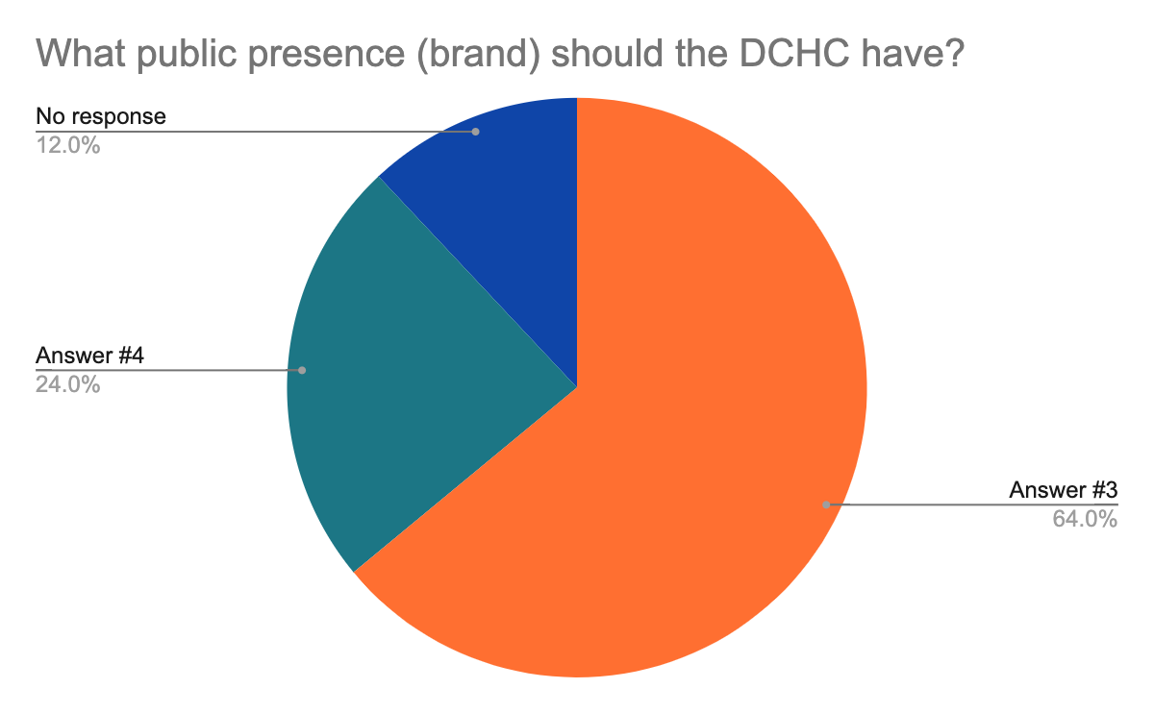

Question 2: Which of the following options best represent your opinion regarding the council’s marketing strategies?

|  |  |  |  |
| --- | --- | --- | --- |
| # | Answer | % | Count |
| 1 | DCHC should market itself more to reach a broader audience | 9.52% | 2 |
| 2 | DCHC should market itself less in order to focus on information sharing among its members | 0.00% | 0 |
| 3 | DCHC should market itself purposefully through: council member outreach, the local papers and media, the chamber of commerce, the all-island boards of health, holding listening sessions to meet the community where they are, etc. | 85.71% | 18 |
| 4 | DCHC should not market itself at all because DCHC is a collaborative organization meant for sharing information internally among its members | 4.76% | 1 |
|  | Total | 100% | 21 |

**n=25**

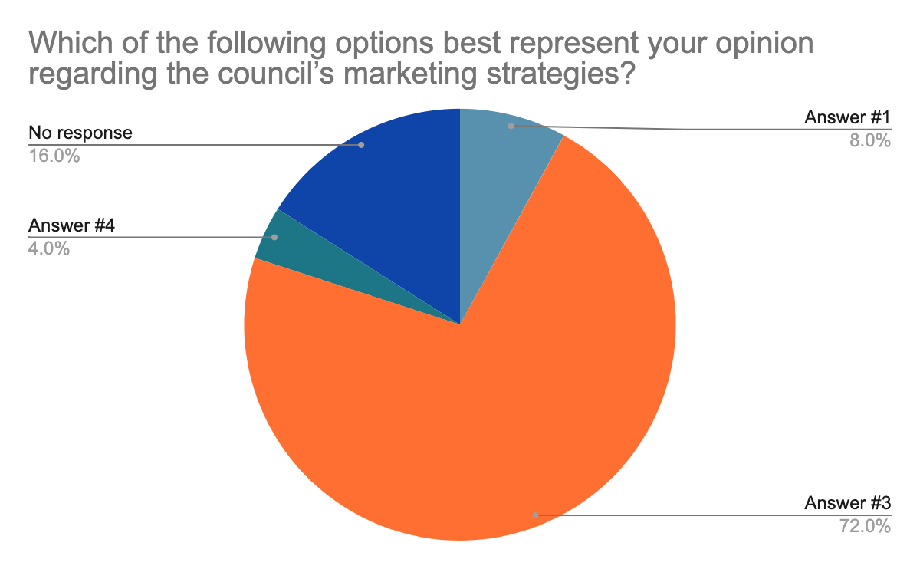

Question 3: Which of the following options best represent your opinion regarding the council’s communication strategies?

|  |  |  |  |
| --- | --- | --- | --- |
| # | Answer | % | Count |
| 1 | DCHC should focus more on how to streamline communication among member organizations and less on communication with the public | 0.00% | 0 |
| 2 | DCHC should focus on enhancing communication with the public using various channels (e-newsletters, e-mailers, the website) on an "as-needed" basis | 22.73% | 5 |
| 3 | DCHC communication to the public should be more regular and purposeful; as such, the council may need to consider dedicating resources (time, personnel) to achieve its communication goals | 40.91% | 9 |
| 4 | DCHC resources would be better utilized by focusing its communication effort on a few channels instead of pursuing several approaches | 36.36% | 8 |
|  | Total | 100% | 22 |

**n=25**

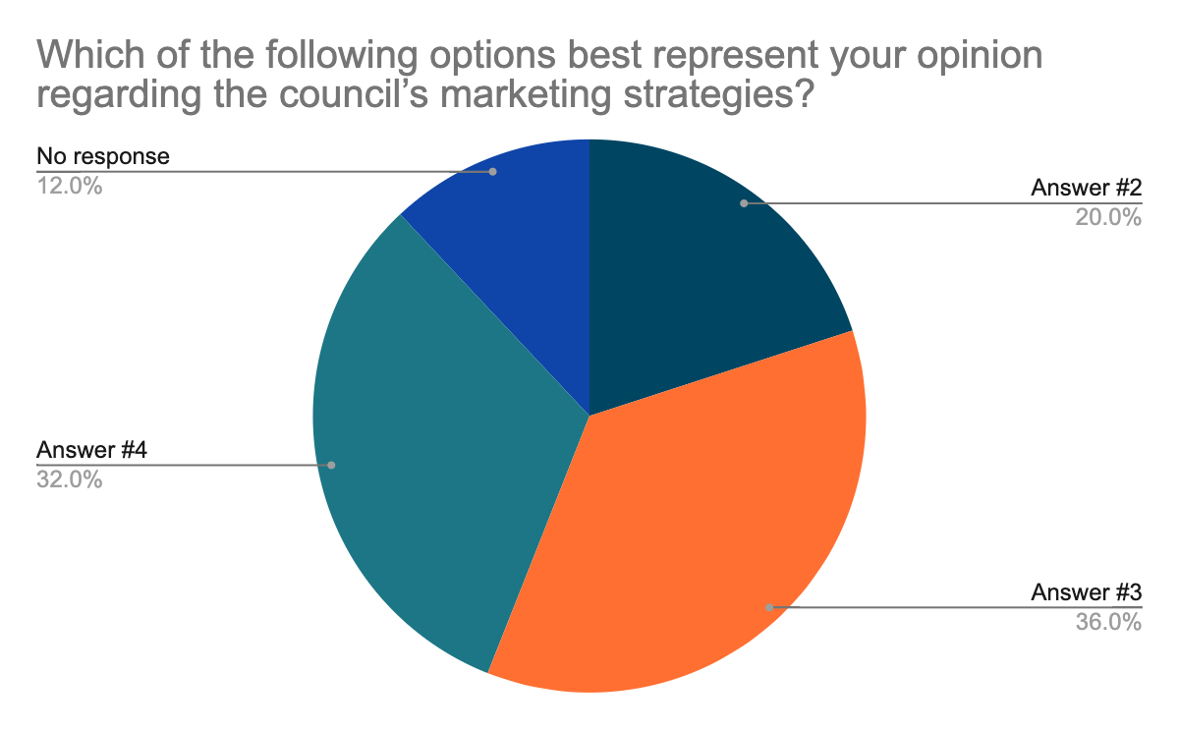

Question 4: Which of the following options best represent your opinion regarding the council’s approach to ownership of web and other communication content?

|  |  |  |  |
| --- | --- | --- | --- |
| # | Answer | % | Count |
| 1 | All members associated with the DCHC should consistently provide information about relevant health-related services available from their respective agencies; as such, they would be responsible for preparing and maintaining content to be posted on the DCHC website regarding their services | 40.00% | 8 |
| 2 | All members associated with the DCHC should consistently provide information about relevant health-related services available from their respective agencies; however, preparing and publishing content for the DCHC website should rest solely on the communication committee | 25.00% | 5 |
| 3 | All meeting minutes, presentations, council contact information, etc should be shared publicly on the website | 25.00% | 5 |
| 4 | All meeting minutes, presentations, council contact information, etc should be uploaded to the website but should be accessible only to council members and to the public in a limited fashion | 10.00% | 2 |
|  | Total | 100% | 20 |

**n=25**

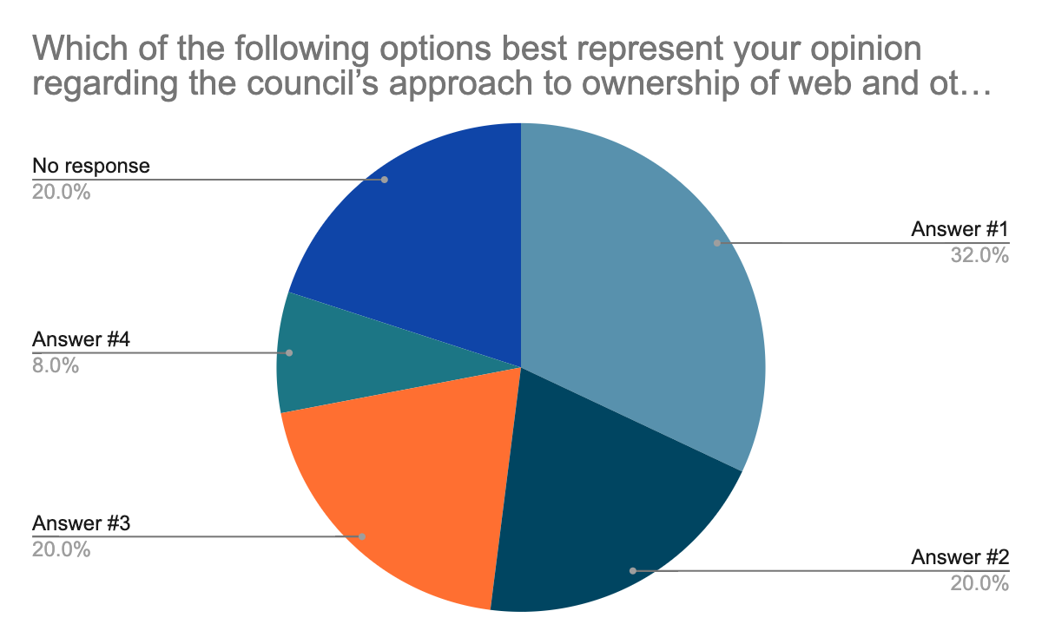

Question 5: Should the DCHC consider other marketing and communications opportunities such as: sponsorships (e.g., Diaper Bank), endorsements (e.g., Housing Bank), partnerships (e.g., MV Hospital Vax Drive).

|  |  |  |  |
| --- | --- | --- | --- |
| # | Answer | % | Count |
| 1 | Yes | 40.91% | 9 |
| 2 | Maybe | 36.36% | 8 |
| 3 | No | 22.73% | 5 |
|  | Total | 100% | 22 |

**n=25**

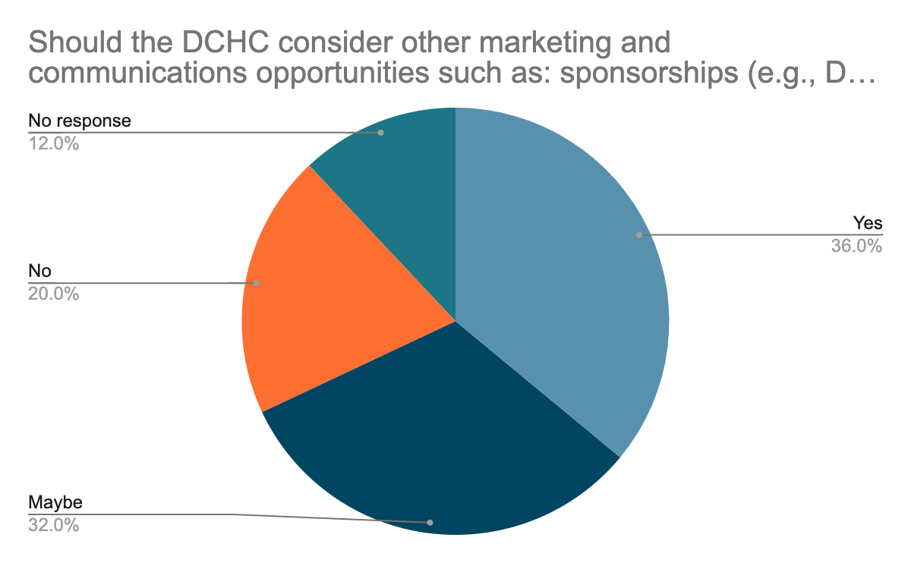

2. Gantt chart outlining recommended actions to enhance the council’s public presence

