Martha’s Vineyard Boards of Health
Weekly positive COVID-19 Case report
January 9th through January 15th, 2022
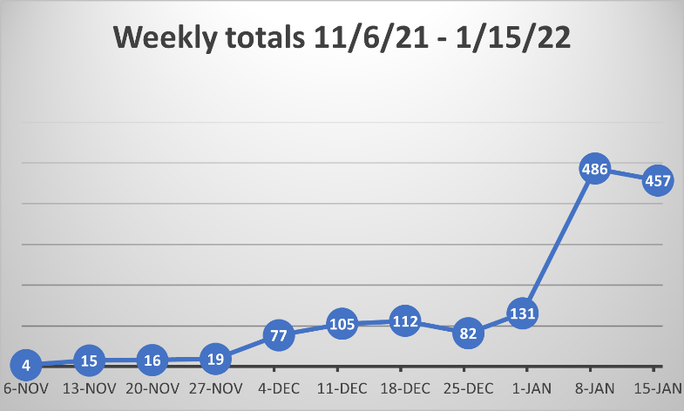
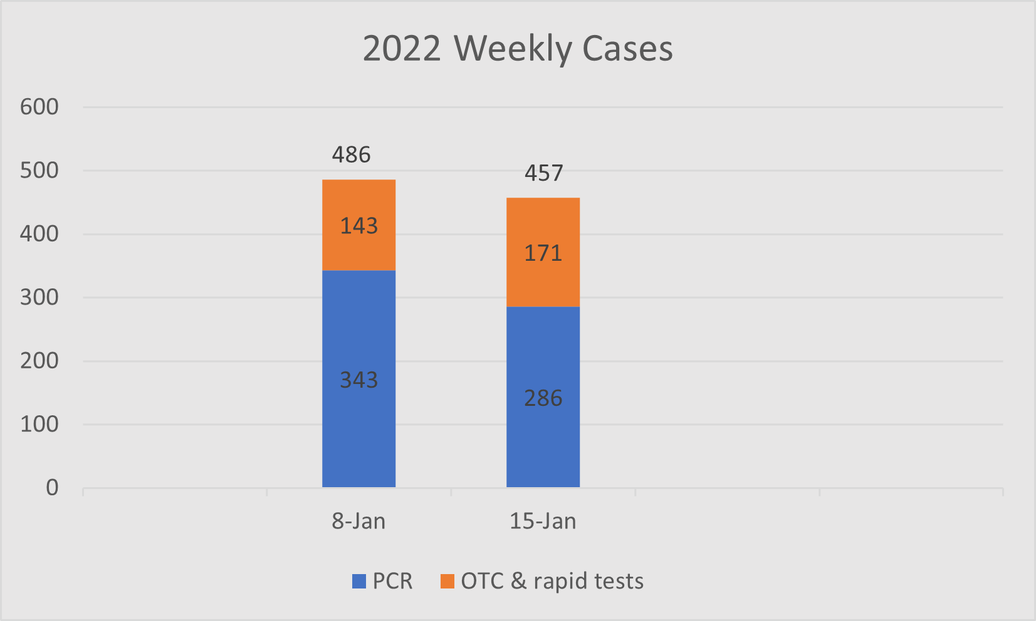
457 positive cases
(148 MVH, 75 TestMV, 47 School Surveillance, 7 Tribe, 9 other, 7 in-school rapid tests, 164 OTC)
202 in progress, 255 completed
133 symptomatic, 44 asymptomatic, 280 unknown
124 vaccinated (at least 2 doses), 4 partially vaccinated, 50 unvaccinated, 279 unknown
5 suspect cases

221 male
236 female

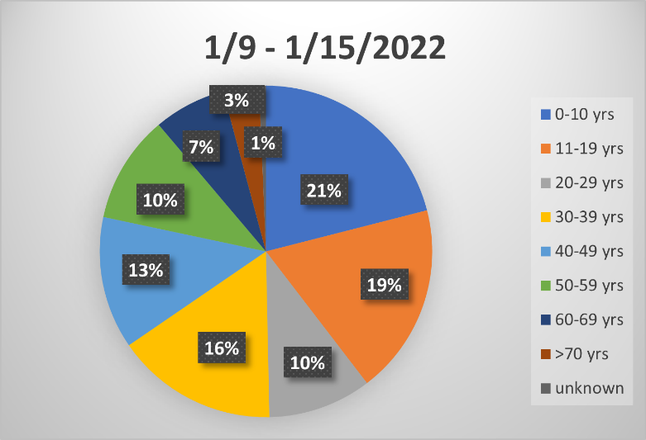
Current week age breakdown
0-10 96
11-19 85
20-29 46
30-39 72
40-49 59
50-59 48
60-69 32
70+ 16
Unknown 3

Cases to date
3,851 total cases (positive and probable cases)
3,594 positive cases (pcr and post 1/1/22 OTC positives)
1,776 male
1,816 female
2 other

2022 cases

January

1/1 – 1/8 486 cases
486 completed
183 symptomatic, 31 asymptomatic, 272 unknown
184 vaccinated (at least 2 doses0, 16 partially vaccinated, 40 unvaccinated, 246 unknown

2020 cases 2021 cases
533 total cases 2,118 total cases
January no cases July 18 cases January 302 cases July 54 cases
February no cases August 15 cases February 91 cases August 335 cases
March 9 cases September 8 cases March 108 cases September 107 cases
April 10 cases October 32 cases April 316 cases October 92 cases
May 10 cases November 191 cases May 149 cases November 71 cases
June 5 cases December 235 cases June 8 cases December 485 cases

TEST SITE DATA:

Test MV MV Hospital (mvhospital.org) Aquinnah
Medically observed nasal self-swab Medically collected nasopharyngeal swab Self-administered saliva test
Total Tested 47,006 Total tested 32,474 Total tested 756
Positive tests 690 Positive tests 2,242 Positive tests 4
Negative tests 46,316 Negative tests 30,224 Negative tests 752
Hospitalizations 2
(as of Friday 1/14/22)

